Exercise 4: Functions

**Scenario 1:** Calculate the age of customers for eligibility checks.

* + **Question:** Write a function CalculateAge that takes a customer's date of birth as input and returns their age in years.
  + **Solution:**

CREATE OR REPLACE FUNCTION CalculateAge (

p_dob DATE

) RETURN NUMBER IS

v_age NUMBER;

BEGIN

v_age := TRUNC((SYSDATE - p_dob) / 365.25);

RETURN v_age;

END;

/

-- Test the CalculateAge function

SELECT Name, DOB, CalculateAge(DOB) AS Age

FROM Customers;

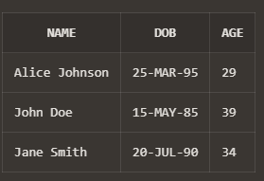

**Scenario 2:** The bank needs to compute the monthly installment for a loan.

* + **Question:** Write a function **CalculateMonthlyInstallment** that takes the loan amount, interest rate, and loan duration in years as input and returns the monthly installment amount.
  + **Solution:**

CREATE OR REPLACE FUNCTION CalculateMonthlyInstallment (

p_loan_amount NUMBER,

p_interest_rate NUMBER,

p_duration_years NUMBER

) RETURN NUMBER IS

v_monthly_installment NUMBER;

v_monthly_interest_rate NUMBER;

v_number_of_payments NUMBER;

BEGIN

-- Convert annual interest rate to monthly interest rate

v_monthly_interest_rate := p_interest_rate / 12 / 100;

-- Calculate the total number of monthly payments

v_number_of_payments := p_duration_years * 12;

-- Calculate the monthly installment using the formula for an annuity

v_monthly_installment := p_loan_amount * v_monthly_interest_rate /

(1 - POWER(1 + v_monthly_interest_rate, -v_number_of_payments));

RETURN v_monthly_installment;

END;

/

-- Test the CalculateMonthlyInstallment function

SELECT CalculateMonthlyInstallment(10000, 5, 10) AS MonthlyInstallment

FROM DUAL;

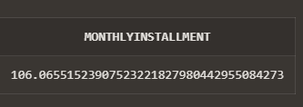

**Scenario 3:** Check if a customer has sufficient balance before making a transaction.

* + **Question:** Write a function **HasSufficientBalance** that takes an account ID and an amount as input and returns a boolean indicating whether the account has at least the specified amount.
  + **Solution:**

CREATE OR REPLACE FUNCTION HasSufficientBalance (

p_account_id NUMBER,

p_amount NUMBER

) RETURN BOOLEAN IS

v_balance NUMBER;

BEGIN

SELECT Balance INTO v_balance

FROM Accounts

WHERE AccountID = p_account_id;

IF v_balance >= p_amount THEN

RETURN TRUE;

ELSE

RETURN FALSE;

END IF;

EXCEPTION

WHEN NO_DATA_FOUND THEN

RETURN FALSE;

WHEN OTHERS THEN

RETURN FALSE;

END;

/